Technical Report

Implement Time-dependent Well Control in GPRS
By Yuanlin Jiang
Revised by Huanquan Pan

Last updating: March 2004

SUPRI-B Industrial Consortium
Department of Petroleum Engineering
Stanford University

1 General description:
In original GPRS, the switching of well control only happens when the physical condition does not satisfy the minimum requirement. For example, the rate control will switch to another method, when the BHP drops below the minimum BHP criterion. And once BHP control is valid, it’s impossible to switch to other controls, because it does not need to satisfy any requirement.

To make the well controls more flexible, I implement a series of time-dependent well control methods. With these new methods, one can specify a well control during a period of time, and can design an arbitrary combination of well controls as well. For example, you can specify the 5000 bbl/day liquid rate control for first 100 days and then use 4000 bbl/day oil rate control for next 50 days, and 3000 psi BHP control to the end of total simulation time.

Furthermore, a new well closing and opening mechanism is formed based on these new well control methods. We can force the well closed for a period of time by absence of well control for that time. If a proper well control is available, the well may reopen automatically.

2 Implementation:
4 new time-dependent well control classes are added in GPRS, “WellTimedBHPCont”, “WellTimedGRateCont”, “WellTimedORateCont”, “WellTimedWRateCont”, which are derived from the classes of corresponding traditional control. Fig. 1 illuminates the relations between the well controls.

Well Ctrl
WRate
ORate
GRate
BHP
TGRate
TBHP
TORate
TWRate

Fig. 1 the relation of well control methods
Since we need to switch the well control at the specified time points, a break time table is added in GPRS, to force the simulator pass by these time points.

Two new keywords “TBHP”, “TORATE” to represent the time-dependent controls are added in. See following example:
# --- well control (producer)----------------
# WCONPROD
# CTRL Btime Etime Qoil minBHP std_den_o
TORATE 0 100 20000 1000.0 49.1
# CTRL Btime Etime BHP
TBHP 100 150 2500.0

“Btime” and “Etime” above represent the beginning and end of the control. The new well controls are very similar to original well control methods. Simply add above lines into the well control part of input files, the new control methods will be activated. This implementation is fully compatible with original version. Original input files can work well without any modification.

3 Results:
In this part, we will focus on testing whether our well closing and opening mechanism works well. The test case is exactly the same as the case in Part I, and this time, we use new time-dependent controls on the producer.

The well control part of input files is list as follows
# --- well control (producer)----------------
# WCONPROD
# CTRL Btime Etime BHP
TBHP 100 150 2500.0
TBHP 10 50 3000.0

The first one is the keyword standing for the well control method. The second and third ones specify a period of time, in which the well control is valid. The last one is the BHP criterion. The order of control methods is not important, since we have already specified the applied time. A well is in the closed state except the specified time. For example, the well is closed except 10 to 50 days and 100 to 150 days.
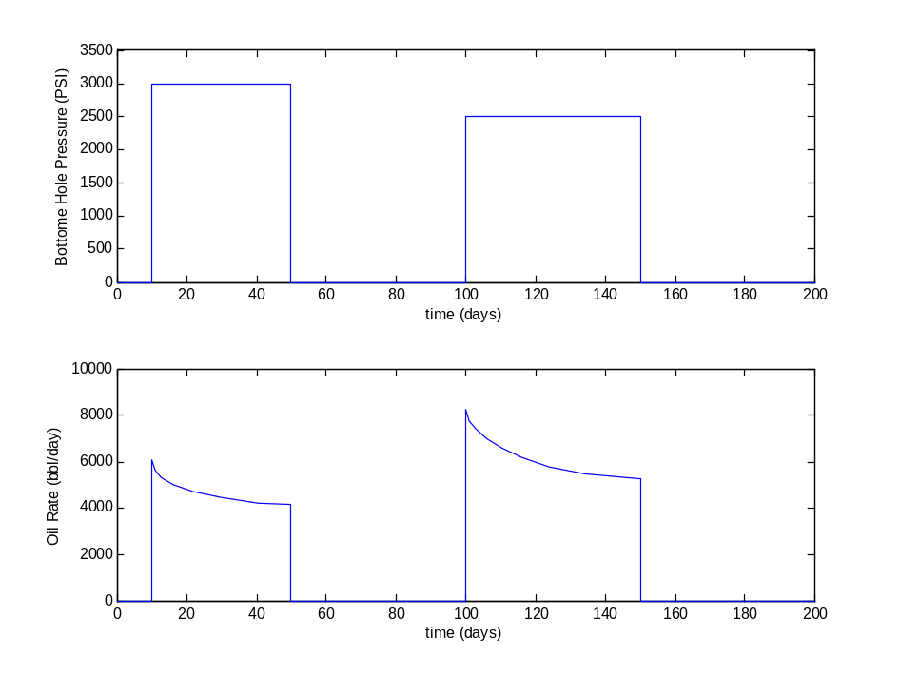
Fig. 7 the pressure of BHP control and the corresponding oil rate
The output file of this case is listed in the appendix. From above plot, we can see that the well is set to be close due to the absence of valid control at the beginning time. At the exact time we specified, the well finds valid control and turn into open status. Once the current control method expires, the well shuts down at once, and it will reopen at later time. Basically, the well works in the way we expect.

Appendix I: Output files of Test Example
Results for well: PROD in the reservoir: RES1

t BHP q(Oil) q(Water)
(days) (psia) (STB/day) (STB/day)
0 Well closed
1 Well closed
2 Well closed
3.55207 Well closed
6.32753 Well closed
10 3000 6074.36 0
11 3000 5610.61 0
12.7483 3000 5317.77 0
16.0009 3000 5035.89 0
21.6822 3000 4727.6 0
29.618 3000 4451.9 0
40.5044 3000 4241.1 0
50 3000 4141.85 0
62.7665 Well closed
65.969 Well closed
70.3651 Well closed
76.3323 Well closed
83.8499 Well closed
92.9902 Well closed
100 2500 8260.04 0
101.147 2500 7753.67 0
103.007 2500 7377.33 0
106.01 2500 6984.61 0
110.354 2500 6571.19 0
116.11 2500 6169.89 0
123.735 2500 5805.48 0
134.347 2500 5500.67 0
149.742 2500 5285.75 0
150 2500 5282.21 0
151 Well closed
152 Well closed
153 Well closed
154.368 Well closed
156.377 Well closed
159.254 Well closed
163.094 Well closed
167.854 Well closed
173.488 Well closed
180.069 Well closed
187.857 Well closed
197.172 Well closed
200 Well closed

Appendix II: Procedure of adding Time Dependent Well Controls to GPRS Structural modification

- [Main.dsp] We have 4 new classes for these new well control methods. Insert the head files (.h) and implementation files (*.cpp) into the workspace and the well folder in GPRS.
- [Well.cpp] Add 4 new head files to well.cpp file. Add 4 new keywords to the constructor Well::Well(FileIO &fio)
- [Well.h] Add 4 new classes as the friend classes of Well class. (optional, but now, no use)
- [EnumDef.h] Add a new struct TimeBreakCtrl to store the break time list and current time.
- [Main.cpp] Add TimeBreakCtrl tbCtrl to main.cpp file. Declare it as global variable.
- [Field.h, Field.cpp] change a local variable double t into double time, which is a member variable of class Field.
- [Field.cpp] Declare extern TimeBreakCtrl tbCtrl at the beginning of Field.cpp;
- [Field.cpp] In void Field::simulate(), hook up the variable time and TimeBreakCtrl.
assert(time == tbCtrl.Cur_time);
tbCtrl.Cur_time = time;
std::list<double>::iterator BTiter = tbCtrl.BreakTime.begin();
double BreakTime = *(++BTiter); //ignore the first breaktime -- zero;
cout<<"Break Time Table"<<endl; // output the break time table;
std::list<double>::iterator iter1;
for (iter1 = tbCtrl.BreakTime.begin();iter1 != tbCtrl.BreakTime.end(); iter1++)
cout<< *(iter1)<<endl;
etc.
- [Field.cpp] Insert the code in void Field::readData(FileIO &fio) to insert start & end time to break time list.
- [Field.cpp] Include <algorithm> at the beginning, since we use STL function sort() and find()

Logical modification:
In original GPRS, when a well is closed, then it will be killed in the simulator. However, in this new option, the closed well might reopen, so we need to keep them alive and waiting for the time when it might reopen. We need handle the variable mExtra, to avoid the closed but alive well disturbs the normal simulator.
- [reservoir.cpp] In void Reservoir::calcProps(), modify the code which scans wells, we calculate the well property even it is closed
- [well.cpp] In void Well::initialize(), change the code which handles mExtra. Rewrite void Well::calcProps(), to make it work even when the well is closed.
- [well.cpp] In void Well::switchWellCont(), change the code to reset the closed well to be open if we have valid well control method.

Minor modification:
- [reservoir.cpp] In void Reservoir::report(double t, bool printDebug) & void Reservoir::setupWellOutput(), some tiny modifications are made.

